# SyncUp Mobile App User Manual

# 

SyncUp is a social networking and events platform created to unite individuals based on their common music tastes and activities. Whether you want to explore new local music events, meet like-minded people, or organize your own gatherings, SyncUp helps you easily engage with your community.

The application provides a customized experience through the option for users to choose their preferred music genres, affecting the events shown on their main page. Users have the option to look through future events, participate in or organize events, and can also provide input on music preferences for specific gatherings to influence the overall experience. SyncUp's user-friendly layout consists of an efficient navigation system, customizable profiles, and functions such as instant notifications and event recommendations based on location, guaranteeing that users stay up-to-date on important events

## **Table of Contents**

1. **Introduction**
   1. Overview of SyncUp
   2. Purpose of the App
   3. Key Features
   4. System Requirements
2. **Getting Started**
   1. Registering a New Account
   2. Logging In
   3. Resetting Password
3. **Main Features**
   1. Profile Setup and Management
   2. Home Page Overview
   3. Viewing and Joining Events
   4. Hosting an Event
   5. Genre Selection
   6. Upcoming Events
   7. Viewing Event Details
   8. Voting on Event Genres
4. **Navigation & Settings**
   1. Navigation Bar and Icons
   2. Managing Preferences and Favorite Genres
   3. Updating Profile Information
5. **Troubleshooting**
   1. Common Issues and Solutions
   2. Contact Support
6. **FAQs**
7. **Legal Information**
   1. Terms of Service
   2. Privacy Policy

## **1. Introduction**

### **Overview of SyncUp**

SyncUp is an app for mobile devices created to unite individuals by linking them based on common interests and preferred activities. If you are looking for concerts, festivals, or special community events, SyncUp provides a user-friendly platform to discover, participate in, and organize events in your area. SyncUp promotes a social experience that goes beyond online interaction by assisting users in connecting with like-minded individuals.



## **Purpose of the App**

SyncUp aims to simplify the process of finding and participating in events, while also connecting with similar people. Users have the ability to accomplish tasks via the application.

* Discover upcoming local events.
* Participate in activities that match their preferences.
* Organize their own gatherings and extend invitations to others.
* Take part in choosing music genres to improve your event experience



## **Key Features of the App**

SyncUp offers many innovative features to enhance user experience:

* **Event Discovery:** Browse a curated list of events based on your preferences.
* **Hosting Events:** Easily create and manage your own events, with customization options for date, location, and genre.
* **Genre Voting:** Participate in voting on event genres, creating a personalized musical experience for attendees.
* **User Profiles:** Customize your profile with your favorite genres and event preferences.
* **Real-Time Event Updates:** Receive notifications for updates on events you’re attending or following.



## **System Requirements**

* **Operating System:** Android 8.0 or later
* **Device Compatibility:** Android devices
* **Internet Connection:** Required for initial setup, event browsing, and updates

## **2. Getting Started**

### **Registering a New Account**

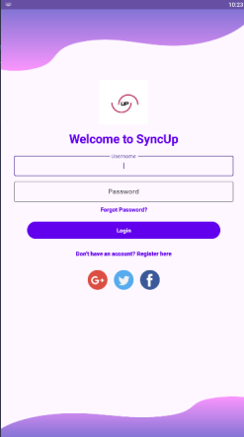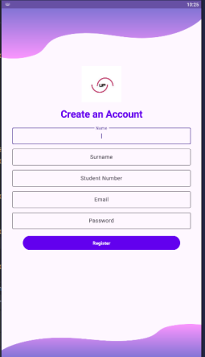

* **Open the App:** Launch the SyncUp app on your device.
* **Navigate to the Register Page:** On the splash screen, tap "Don’t have ab account? Register here" to create a new account.
* **Enter User Details:**
* **Full Name**: Enter your full name as you’d like it to appear on your profile.
* **Student Number:** enter in your student number
* **Email Address**: Provide a valid email address. This will be used for account verification and password recovery.
* **Password**: Choose a strong password and enter it in both the "Password" and "Confirm Password" fields.
* **Optional Social Login**: For faster sign-up, choose to register using your Twitter, Google, or Facebook account.
* **Complete Registration**: Tap the **"Sign Up"** button. You’ll receive a confirmation email or prompt to verify your account.

### **Logging In**



1. **Navigate to the Login Page**: If you already have an account, tap “Login” from the splash screen.
2. **Enter Credentials**:
   1. **Username**: Enter your registered email.
   2. **Password**: Enter your password.
3. **Log In**: Tap the **"Login"** button to access your account.
4. **Forgot Password**: If you have trouble logging in, tap "Forgot Password" to initiate a password reset.

Password reset

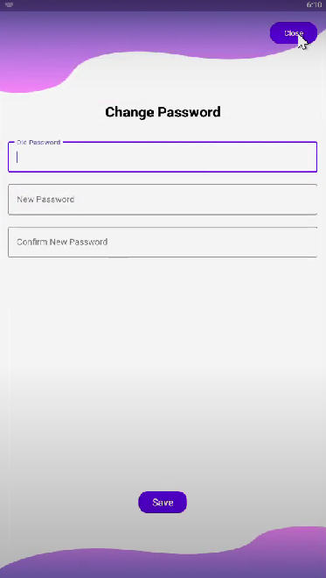  
Choose "Forgot Password": Click "Forgot Password" on the login screen.  
Input Email Address: Please provide the email address linked to your account.  
Please monitor your email account for a link to reset your password that will be sent to you. Adhere to the guidelines in order to reset your password.

# 3. Main Features

## Profile Setup and Management

The Profile page is designated for individual use, allowing for the addition of details, preferences selection, and customization of the SyncUp experience.

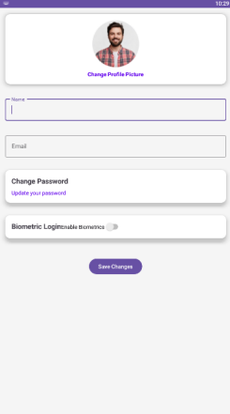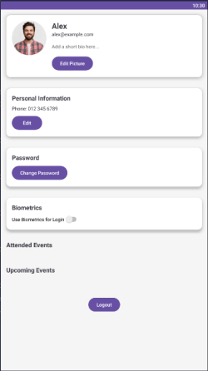

**Accessing the Profile Page**:

* Tap on the **Profile icon** in the navigation bar at the top of the screen.

**Setting Up Your Profile**:

* Enter details such as your **name** and **bio** to personalize your profile.

**Add Profile Picture**: Tap the profile image area to upload a picture from your device.

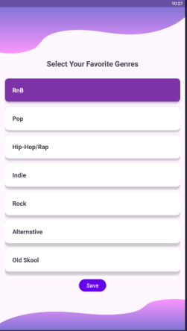

**Choosing Favorite Genres**:

* Use checkboxes to select your favorite music genres. This helps SyncUp personalize event recommendations based on your tastes.
* Available genres include New R&B, Old School, House, and Trap, with more options available as you scroll.



* **Editing Profile Information**:
* To update any information, go to the Profile page and select the relevant field.
* Tap "Save" to confirm changes.

### **3. Main Features**

This section provides an overview of the primary features in the SyncUp app, helping you navigate and make the most of your user experience.

#### **Profile Setup and Management**

The Profile page is your personal space within the app, where you can add information, select preferences, and customize your SyncUp experience.

1. **Accessing the Profile Page**:
   1. Tap on the **Profile icon** in the navigation bar at the bottom of the screen.
2. **Setting Up Your Profile**:
   1. Enter details such as your **name** and **bio** to personalize your profile.
   2. **Add Profile Picture**: Tap the profile image area to upload a picture from your device.

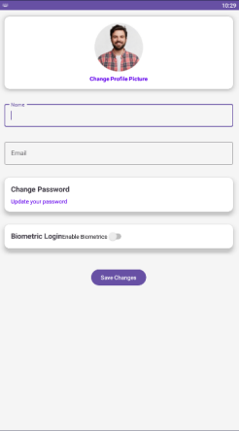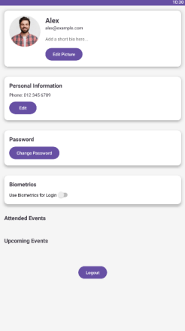

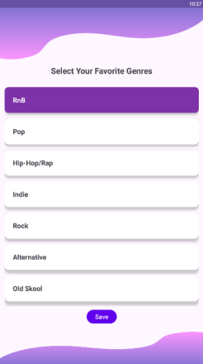

1. **Choosing Favorite Genres**:
   1. Use checkboxes to select your favorite music genres. This helps SyncUp personalize event recommendations based on your tastes.
   2. Available genres include New R&B, Old School, House, and Trap, with more options available as you scroll.

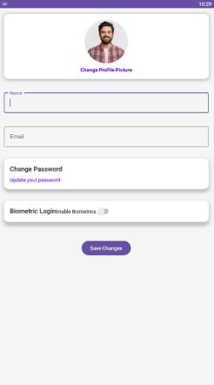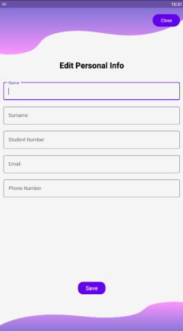

1. **Editing Profile Information**:
   1. To update any information, go to the Profile page and select the relevant field.
   2. Tap "Save" to confirm changes.

## Home Page Overview

The main dashboard is the Home Page where you can see upcoming events, discover event categories, and use app features.

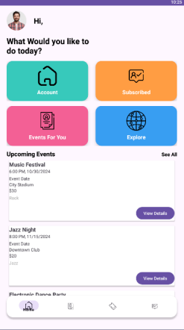

1. **Upcoming Events List**:

* The main page shows a selection of upcoming events that match your interests.
* Details such as the Event Name, Date, Time, Location, and Genre are included in each event entry.

2. **Navigation Toolbar**:

* The navigation bar at the bottom of the screen provides quick access to key sections like Home, Profile, Events, and Notifications.

3. **Exploring Events**:

* Scroll through the list to explore various events. Tap on any event to view detailed information and join.

#### **Viewing and Joining Events**

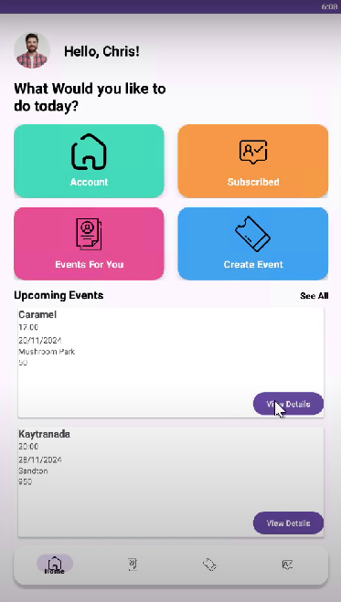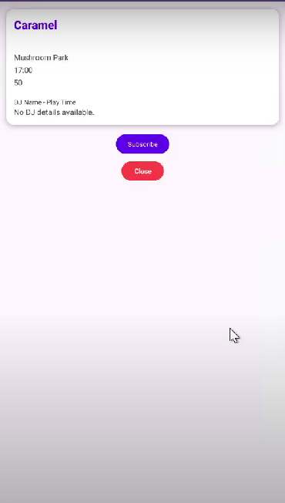

Find events that interest you and join with a single tap to connect with like-minded individuals.

1. **Accessing Events**:

* On the **Home Page**, scroll through the list of available events or use filters to refine your search.

1. **Viewing Event Details**:

* Tap on an event to open its detailed view, which includes:
  + Event **name, description, location**, and **schedule**.
  + A list of attendees and comments for additional insights.

1. **Joining an Event**:

* Tap **"Join Event"** on the event page. You’ll be added to the event list, and it will appear in your "Upcoming Events" tab.

1. **Sharing Event Details**:

* Use the share icon to send event information to friends via social media or messaging apps.

## Hosting an Event

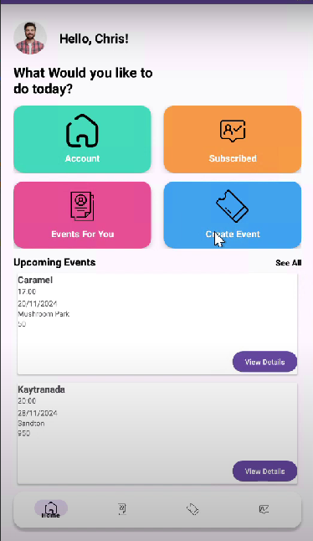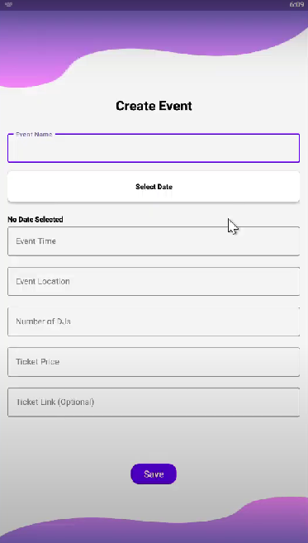

SyncUp simplifies the process of hosting and arranging your own events. You have the ability to make events, establish preferences, and bring in other users.

1. **Starting a New Event**:

* Tap the **Plus (+)** icon on the Home Page to open the "Host Event" page.

1. **Enter Event Details**:

* **Event Name**: Provide a catchy name for your event.
* **Location**: Add a specific location or set it as “To be announced.”
* **Start and End Date/Time**: Select the date and time range for your event.
* **Genre**: Choose a music genre for the event to give attendees an idea of what to expect.

1. **Saving and Publishing the Event**:

* Once you’ve filled in the event details, tap **"Save"** to publish the event.
* The event will now appear in the Upcoming Events list, where other users can view and join.

## Genre Selection

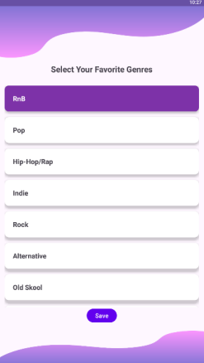

The Genre Selection option enables users to indicate their music tastes, assisting SyncUp in tailoring the events presented to them.

1. **Accessing Genre Selection**:

* From the Profile page, select **"Genres"** to open the genre selection screen.

1. **Selecting Favorite Genres**:

* Use checkboxes to select genres like R&B, House, Trap, and more.
* Selected genres will impact the type of events recommended to you in the Home and Upcoming Events sections.

1. **Saving Preferences**:

* Tap "Save" to update your preferences, which will immediately affect event recommendations.

## Upcoming Events

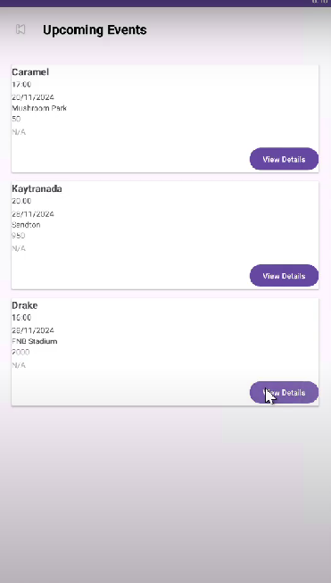

The Upcoming Events page displays a thorough list of events you have indicated interest in or participated in.

1. **Accessing Upcoming Events**:

* Tap on **"Upcoming Events"** from the navigation bar or home screen shortcut.

1. **Viewing Event Information**:

* Each event card includes details like the **event name, location, date**, and **genre**.

1. **Filtering Events**:

* Use filters to sort events by **date, location**, or **genre** to quickly find events you’re interested in.

## Viewing Event Details

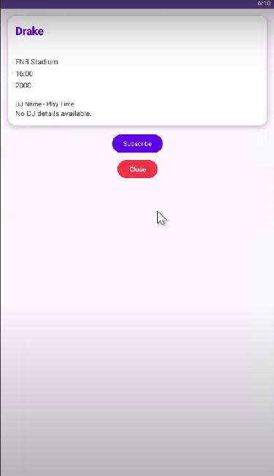

Every SyncUp event has a specific page with detailed information to assist you in determining its suitability for you.

1. **Accessing Event Details**:

* Tap on an event in the Upcoming Events or Home Page list.

1. **Detailed Information**:

The event details page includes:

* **Description** of the event.
* **Location**, with a map view for easy navigation.
* **Attendees List** showing other users who plan to join.

1. **Joining from Event Page**:

* Use the **"Join Event"** button to confirm your attendance.

1. **Map View**:

* For location-based events, a map is available to provide directions.

## Voting on Event Genres

On certain occasions, you might have the opportunity to vote on the types of music to be played, improving the group experience of the event.

1. **Accessing Genre Voting**:

* Open the event page, and if voting is available, you’ll see the **"Vote on Genre"** section.

1. **Choosing Genres**:

* Select from available genres like R&B, House, or Trap.

1. **Submitting Your Vote**:

* Tap **"Vote"** to submit. Your vote helps shape the musical theme of the event.

# 4. Navigation & Settings

This part offers information on how to move around the app's layout and adjust configurations to fit your liking.

## Navigation Bar and Icons

The bottom screen navigation bar is created for simple switching between app's main sections. Here’s an overview of the icons and their functions:

1. **Home Icon**:

* Takes you to the Home Page, where you can see the upcoming events list and other suggested activities.

1. **Profile Icon**:

* Leads you to your profile page where you can update profile information, choose preferred genres, and see events you have participated in or organized.

1. **Event Icon**:

* Immediately access the "Upcoming Events" section to view events you're interested in and have already RSVP'd to. This allows easy access to all upcoming events in a single location.

1. **Notifications Icon**:

* Check out latest notifications such as reminders for upcoming events, updates from hosts, and other important alerts related to your profile and event engagements.

## Managing Preferences and Favorite Genres

In SyncUp, you can customize your experience by choosing preferences and picking favorite genres.

1. **Accessing Preferences**:

* Go to your **Profile** page and tap on "Genres" to view a list of music genres available in the app.

1. **Selecting Favorite Genres**:

* Check the genres that interest you most. These preferences will influence the type of events recommended on your Home Page.

1. **Saving Changes**:

* Once you’ve selected your preferred genres, tap **"Save"** to update your profile.

1. **Adjusting Preferences Over Time**:

* You can modify your genre selections at any time by revisiting this section, allowing SyncUp to keep your recommendations relevant.

## Updating Profile Information

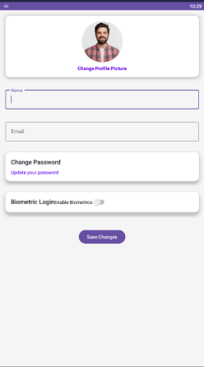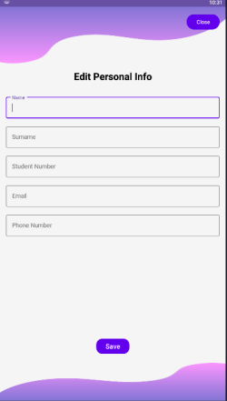

You can modify your personal information and control your account settings from your Profile page.

1. **Profile Information**:

* Edit details such as **Name, Bio,** and **Profile Picture** to keep your profile updated.

1. **Password Management**:

* To change your password, go to **Settings** under your Profile and select **"Change Password"**. Follow the prompts to update your password securely.

1. **Contact Information**:

* Ensure your email address is up-to-date to receive notifications and password recovery emails.

1. **Saving Profile Changes**:

* After making any updates, tap **"Save"** to confirm changes to your profile.

# 5. Troubleshooting

#### This part offers advice on dealing with typical problems that users may face when utilizing the SyncUp app. **Common Issues and Solutions**

1. **Unable to Log In**:
   1. **Solution**: Resolve the issue by verifying that the email and password you are using are correct. If you can't remember your password, click on the "Forgot Password" link on the login page to reset it.
2. **App Crashing or Freezing**:
   1. **Solution**: Attempt to restart the application. If the problem continues, ensure you have the most up-to-date version by going to the App Store or Google Play Store. Frequently updating the app can solve these problems.
3. **Event Details Not Loading**:
   1. **Solution**: Verify your internet connection to make sure you are successfully connected. If the problem persists, attempt to sign out and sign back in.
4. **Notifications Not Working**:
   1. **Solution**: Access the Settings on your device and make sure that notifications are turned on for SyncUp. If notifications are not functioning, try restarting the app or updating it.
5. **Issues with Genre Selection or Voting**:
   1. **Solution**: Make sure you have a reliable internet connection, as these functions need real-time data access. If the issue continues, attempt to delete the app's cache within your device's settings.

# 6. FAQs

Listed below are responses to common inquiries about the SyncUp application.  
  
1. What is the process of setting up an account on SyncUp?

* Navigate to the Registration page, input your information (name, email, password), and click on "Sign Up". You have the option to sign up using Google or Facebook as well.

2. Is it possible for me to participate in several events simultaneously?

* Certainly, feel free to participate in as many events as you desire. Every event that you join will be displayed on your Upcoming Events page.

3. What is the process for organizing an event?

* To make a new event, select the Plus (+) symbol on the Home Page. Enter the event information, such as title, place, and type, before saving to post the event.

4. Is it possible to modify my genre preferences once they have been established?

* Definitely. Navigate to your Profile page, then click on "Genres" to make changes to your preferences.

5. What is the process for resetting my password?

* In case you forget your password, simply visit the Login Page, click on "Forgot Password," and then follow the instructions to reset it through email.

6. Which devices can be used with SyncUp?

* SyncUp can be downloaded on iOS devices running on Android devices running on Android 8.0 or later.

# 7.Legal Information

This section covers the terms of service and privacy policy for the SyncUp app.

#### **Terms of Service**

By using SyncUp, you agree to our Terms of Service, which outline your rights and responsibilities as a user. SyncUp is not liable for any issues or damages arising from event attendance or interactions within the app. Users are expected to follow community guidelines and behave respectfully in all interactions.

#### **Privacy Policy**

SyncUp values your privacy. We only collect the data necessary to provide our services, such as email, location (for event recommendations), and preferences. Your data is stored securely, and we do not share personal information with third parties without consent. Please review our full Privacy Policy on our website or within the app for more details.